Let’s Celebrate
Customer Appreciation
Sunday March 8th
9am – 5pm

Special activities throughout the day

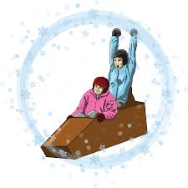
Cardboard box race @5:00
(Cardboard and Duct Tape Only)

Special Pricing:
$15 Lift Tickets $32 Lift/Rent/Beginner Lesson
$105 Family Max w/Beginner Lessons

